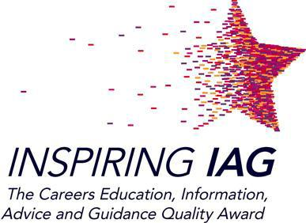

**Code of Practice**

**St Joseph’s RC High School** is working towards the Inspiring **IAG Gold Award**.

The aim of the award is to:

1. Ensure young people get the support they need to make well

informed, realistic decisions about their future through careers

education, information, advice and guidance.

2. Have appropriate, up to date, accurate and impartial information

and resources that all young people can access regardless of

race, gender, religion, ability, disability, social background or sexual

orientation.

3. Ensure the organisational policies relating to careers education,

information, advice and guidance (CEIAG) are up to date and

regularly reviewed and reﬂect this code of practice.

4. Empower young people by informing them of how they can access

CEIAG to help them plan their future and make well informed,

realistic decisions.

5. Offer all young people access to impartial and independent1 careers

guidance by a qualiﬁed2 guidance professional, at a time and place

that suits their needs.

6. Ensure that all staff working with young people are offered and

access ongoing training about qualiﬁcations/progression pathways

and other relevant subjects.

7. Work in partnership, where appropriate, with opportunity providers

including employers, FE and training providers, and youth support

services.

8. Working with parents/carers to offer them information, advice and

guidance to help them, help their son/daughter.

9. Involve young people in the design, delivery and evaluation of

CEIAG programmes.

10. Promote equality of opportunity, celebrating diversity, challenging

stereotypes and raising aspirations.

©2012 The IIAG Management Group

All rights reserved

Updated August 2013

School and College Version